Antibiotics
Antibiotics are compounds that play an important role in antibacterial chemotherapy. Penicillins were accidentally discovered by Alexander Fleming in 1929, and crystalline penicillins were obtained by Flory and his colleagues in 1940. In 1944 important events occurred, such as the isolation of streptomycin sulfate from strains of Streptomyces griseus and the introduction of many biotechnologically prepared antibiotics into clinical practice. Currently, synthetic and semi-synthetic antibiotics are obtained from compounds obtained by biotechnological methods.
Antibiotics are the main drugs used in the treatment of infectious diseases in medicine.
About 5,000 years before written history, Chinese literature mentions the use of rotten plants to treat wounds. But scientifically, in research conducted by Pasteur and Joubert in 1877, it was established that two microorganisms kill each other. В 1889 г. Vieumen used the term "antibios", and thus the concept "antibiotic" appeared. This term is still used in modern medicine.
According to Wekman's scientific statement: antibiotics are formed as secondary metabolites in the metabolism of bacteria, fungi and actinomycetes and have a lethal effect on microorganisms. However, many antibiotics currently used in clinical practice are synthesized as secondary metabolites of microorganisms such as fungi and bacteria.
When antibiotics are grouped according to their chemical structure, they are classified according to the mechanisms of action on bacteria. Mechanisms of action of antibacterial preparations and antibiotics are studied and divided into the following groups.
1) β-lactam antibiotics
2) Aminoglycoside antibiotics
3) Antibiotics of the tetracycline group
4) Macrolide antibiotics
5) Antibiotics of the polypeptide group
6) Lincomycin group antibiotics
7) antibiotics of the chloramphenicol group
8) Antibiotics of different structure
β-lactam antibiotics
This group of compounds was introduced into clinical practice in 1929. bacteriologist Alexander Fleming with the discovery of the antibacterial action of Penicillinum Notatum in 1940. Flory's group with the preparation of crystalline penicillin from Penicillinum notatum. Currently, many antibiotics with a β-lactam structure are used in the clinic against various bacterial infections.
The chemical structure and date of manufacture of these compounds are shown below.
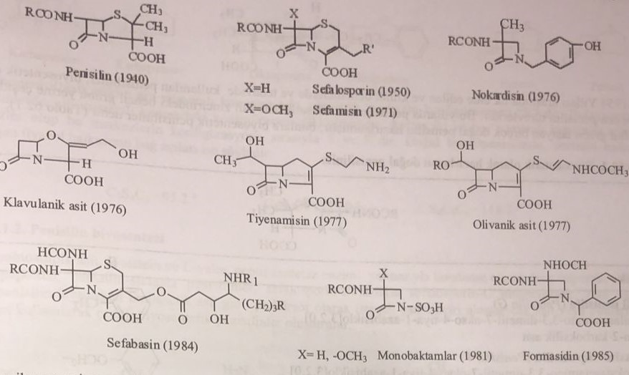
All these natural compounds obtained by fermentation from various microorganisms have a common β-lactam structure. That is, all compounds form the structure of 1-azocyclobutane. When considering compounds that preserve this basic structure, and many synthetic compounds, it is found that beta-lactams have the following basic structure.
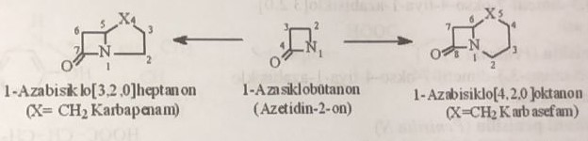
In addition to the formation of the 1-azocyclobutanone structure of these compounds, there are also condensed bicyclic forms combined with a five- or six-membered heterocyclic or cycloalkane structure. These main bicyclic structures are carbapenes, oxopenes, penams and 1-azobicyclo according to the combination –CH2-, -O-, -S- (methylene, oxa, thia) as functional group X. [4,2,0] Octanones They are variously called carbazepam, oxozepam and cefamom. Compounds that preserve a double bond between the second and third states are called carbapenems, oxopenems, penems, or carbazephems, oxozepems, and cephems, respectively.
Beta-lactam antibiotics are mainly studied in 4 groups.
1) Penicillins: 1-azabicyclo[3.2.0]heptanone
2) Cephalosporins: 1-azabicyclo[4.2.0]octanones
3) Monobactams: 1-azacyclobutanone
4) Carbapenem
Penicillin
Natural penicillins
The penicillin group, the first representative of antibiotics, penicillin G, was obtained by the Flory group as a secondary metabolite from the culture of Penicillium notatum and named benzylpenicillin.
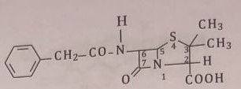
Penicillins obtained between 1940 and 1954, introduced into clinical practice and used in treatment, are penicillin derivatives obtained biosynthetically. During these years, many natural derivatives of penicillin were obtained, in which the benzyl group in the phenylacetic side chain of penicillin was replaced by various alkyl and arylalkyl groups. These penicillins are called biosynthetic penicillins.
These compounds were obtained from the culture of Penicillium notatum and Penicillium chrysogenum and introduced into clinical practice. Among them, penicillin G and penicillin V are most often used in the clinic. Sodium and potassium salts are used to prepare the injection solution of these derivatives. Novocaine salt benzylpenicillin is a depot-effect drug.
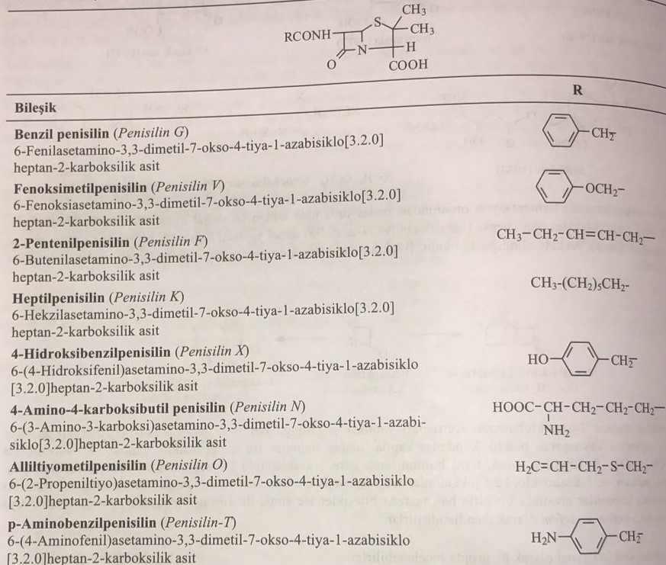
Chemistry and nomenclature of penicillin
The main structure of benzylpenicillin is 6-amino-3,3-dimethyl-4-thia-1-azobicyclo[3.2.0]heptane-2-carboxylic acid, which is called 6-aminopenicilanic acid. Therefore, by adding the pen and am suffixes of penicillin-6-amine to the ring system, the ring system was named penam. The main ring systems in penicillins are:
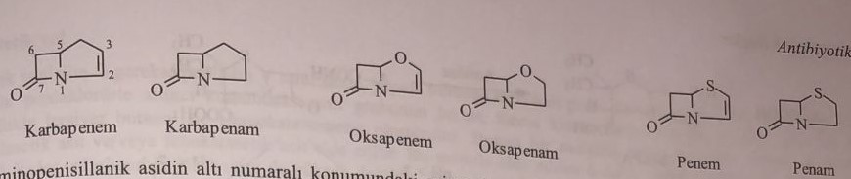
The asymmetric carbon atom in the sixth position of 6-aminopenicilan acid is in the R-configuration. Thus, in all penicillins, the asymmetric carbon atom in the sixth position should be in the R-configuration. At the same time, the carbon atoms in the second and fifth positions are asymmetric, their configurations are S and R, respectively. In natural benzylpenicillin, the valence angle of the thiazole ring, replaced by an azetidine ring, is as follows:
Biosynthesis of penicillin
L-α-aminoadipic acid condenses with L-cysteine and the enzyme L-valine peptide synthetase with the formation of a tripeptide. Penicillins are formed from this tripeptide with the help of penicillin cyclase, and cephalosporin-C with cephalosporin cyclase. At the final stage, benzylpenicillin is formed, and in the presence of phenylacetic acid, other biosynthetic penicillins are formed.
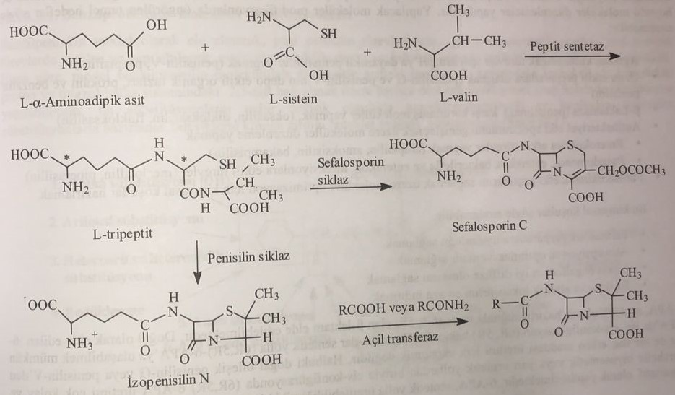
Molecular stability of penicillins
Penicillin is a stable compound in neutral medium. In other environments, it undergoes hydrolysis under the influence of acid and alkali. Degradation products formed by penicillinase and penicillin amidase, which act especially in physiological environment, show similar properties to degradation products formed by acid and alkali action. Decomposition products are 6-aminopenicilanic acid, penicillanic acid and penillic acid. Especially when used orally, it is easily broken down into an inactive form. In the 1950s and 1960s, synthetic antibiotics containing acid-resistant β-lactam derivatives were obtained.
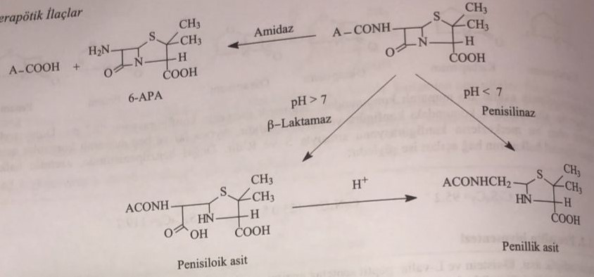
Semisynthetic penicillins
In natural penicillins, there is a dependence between the pH of the environment and the chemical and biological stability of the antibiotic. Since the β-lactam ring, which is a pharmacophore, is active, three-level molecular modifications are carried out that prevent both chemical and enzymatic cleavage of this ring or stabilize the β-lactam ring. The main targets of molecular modifications are:
1) Obtain pH-resistant penicillins for derivatives that will be used orally,
2) To obtain prolonged action preparations (penicillin-G and penicillin-V organic salts of depot effect, novocaine and benzathine penicillins)
3) create molecules protected from β-lactamase (penicillinase) (oxacillin, dicloxacillin, flucloxacillin)
4) Expand the spectrum of antibacterial action
а) Receiving effective derivatives against enterococci (ampicillin, amoxacillin, bacampicillin)
b) Derivatives, effective against cyanobacterial, enterococcal bacteria (meslocillin, piperacillin)
Chemical optimization conditions for improving pharmacokinetic properties are as follows:
1) Ensuring compliance with pharmaceutical preparations
2) To ensure optimal suction
3) To ensure good diffusion through lipoid barriers
4) Minimize cumulative and allergic toxicity
When synthetically obtaining 6-aminopenicilanic acid, β-lactam with trans-(6R,5S) is formed. In the naturally occurring 6-aminopenicilanic acid, it is in the cis-configuration (6R, 5R). Although there is a chemical production method, this method is not economically efficient. It is more convenient to obtain 6-aminopenicilanic acid in the cis-configuration (6R,5R) by one of the biosynthetic or semisynthetic pathways using natural penicillin-G or penicillin-V. 6-aminopenicilanic acid is produced both synthetically and biosynthetically.
Biosynthetic pathway
When adding 0.001% immobilized penicillin-amidase and 10% ammonia solution for pH control to penicillin G or penicillin V compounds, quantitative hydrolysis occurs, and 6-aminopenicillin acid gives phenylacetic acid from penicillin G or phenoxyacetic acid from penicillin V.
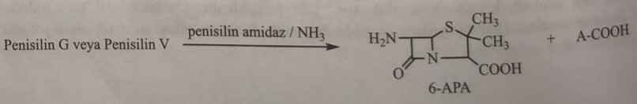
Synthetic way
In the synthesis of both penicillin G and penicillin V, the carboxyl group in the structure is protected with dimethyldichlorosilane. Then, with phosphorus pentachloride, the lactim form of the amide group in the sixth position is converted to the chloride form. In the presence of butanol or tert-butanol, t-butoxyazomethine is obtained. As a result of its hydrolysis with one molecule of water, 6-aminopenicilanic acid and phenylacetic acid or phenoxyacetic acid are obtained. The 6-aminopenicilanic acid obtained by this method is not as pure as the 6-aminopenicilanic acid obtained by the biosynthetic method. In the biosynthetic pathway, the product is very pure and this method is economically viable.
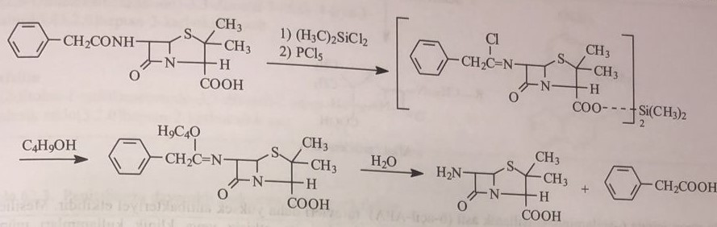
Molecular modification of benzylpenicillins
Benzylpenicillin is considered as a model and its derivatives are obtained. Therefore, in the molecule of benzylpenicillin, substitution occurs on four main functional groups: methylene in phenylacetic acid, carboxyl in the second position, proton in the fifth position, and 2,3-double bonds in the thiazole ring system.
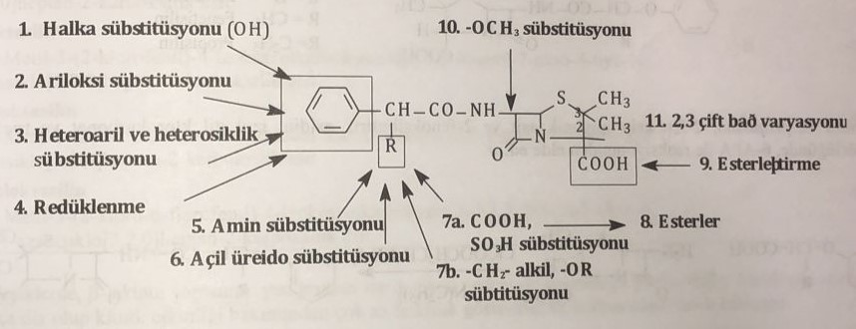
Derivatives of the amino group in position 6 of 6-aminopenicilanic acid
Acylation, alkylation, and Schiff base formation on the single amino group of 6-aminopenicilanic acid can be used to obtain many derivatives.
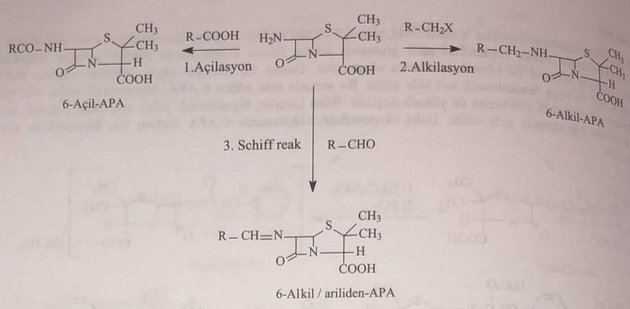
Among these three derivatives, 6-acylaminopenicilanic acid derivatives have a higher antibacterial effect. Other than mesyllene, alkyl/arylidene (Schiff) base and alkyl derivatives are ineffective or have less antibacterial activity than clinical use.
As a result, the combination of the amine group in the sixth position provides activity. When penicillin-V and penicillin-G are compared, it is noticeable that penicillin-V is more effective orally and is more acid-resistant. When the methylene group in benzyl is made asymmetric, compounds such as pheneticillin and propicillin are more effective orally.
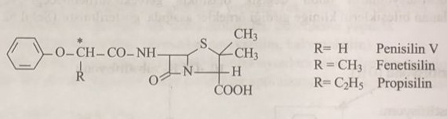
Phenicillin and propicillin are obtained from the reaction of 2-phenoxypropionic acid and 2-phenoxybutyric acid with 6-aminopenicilanic acid under the catalysis of isobutyl chlorocarbonate and triethylamine.
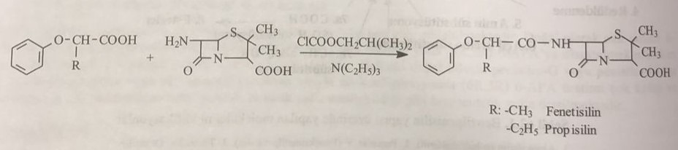
In 1960, there was no penicillin-derived antibiotic resistant to penicillinase secreted by Staphylococcus aureus. Therefore, it was very difficult to treat infectious diseases caused by this bacterium. For this, for the first time, the acylation reaction of 6-aminopenicilanic acid on the amino group with aromatic carboxylic acids was carried out, and stable penicillin derivatives were obtained, which sterically protect the β-lactam ring against penicillinase.
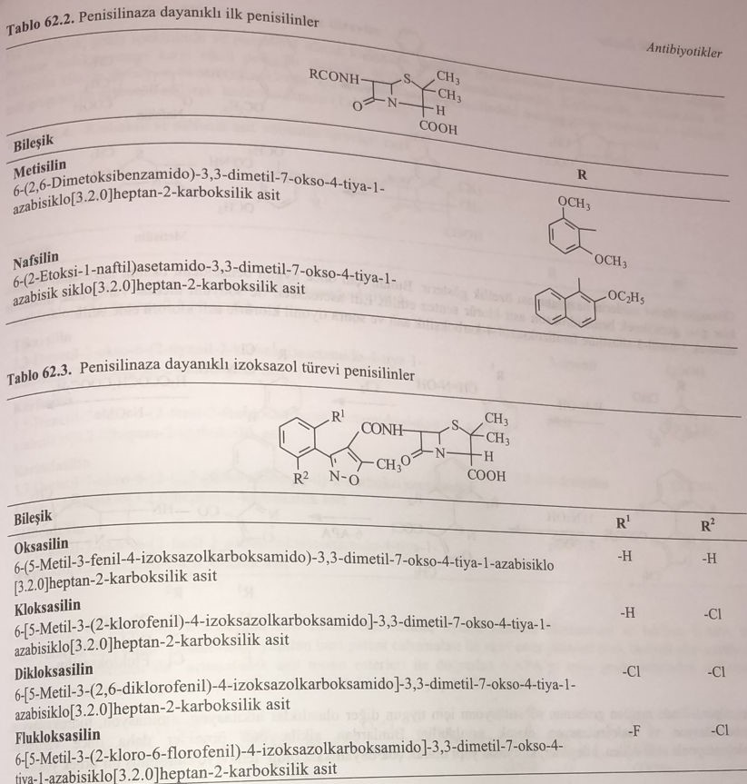
In these compounds, it is established that the β-lactam ring is protected due to the steric effect of the side group. But the range of effects is quite narrow, they differ little from the point of view of clinical usefulness and their application is limited.
Methicillin and Nafcillin are obtained by reacting the corresponding chloride anhydrides with 6-aminopenicillin acid in the medium of sodium bicarbonate or triethylamine. In recent years, during the synthesis of these compounds, isoxazolic acids are directly obtained, which are introduced into the reaction with 6-aminopenicillic acid in the medium of isobutylchlorocarbonate and triethylamine and obtained with a cleaner and higher yield.
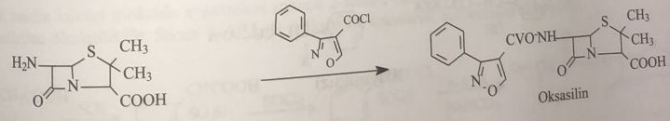
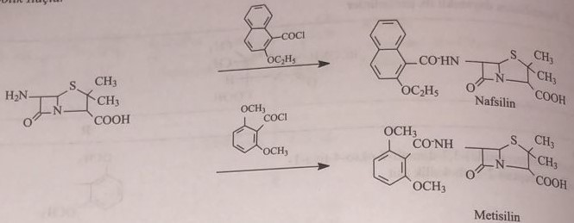
Special reactions are required for the preparation of oxacillin-derived acids. For this, the appropriate benzaldehyde oxime is obtained first. By passing chlorine gas from it, the chloride of benzhydroxymic acid is obtained. 5-methyl-3-substituted phenylisoxazole-4-carboxylic acid is obtained by interaction with ethyl acetoacetate in sodium methylate environment and then with thionyl chloride and acid chloride.
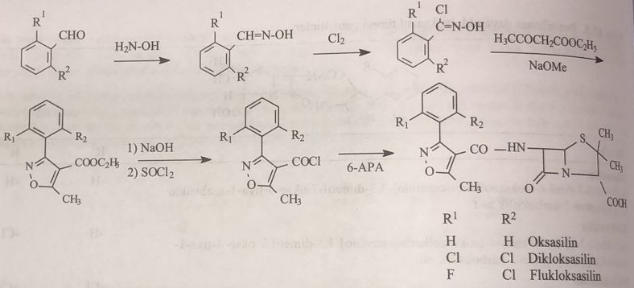
In benzylpenicillin, alkylation, amination, hydroxylation, carboxylation, and halogenation reactions are carried out to connect the functional group to the methylene group. Compounds obtained by halogenation are chemically unstable compounds.
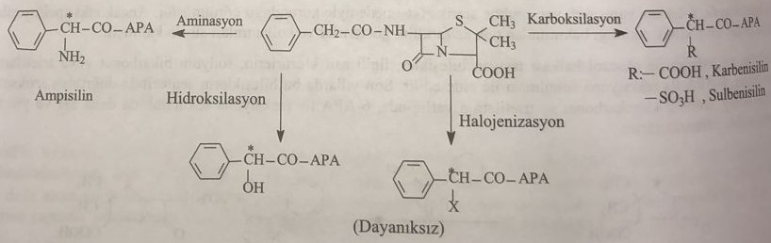
Carboxylic and sulfonic acid derivatives
These compounds have entered clinical practice as broad-spectrum and parenterally effective penicillin derivatives, especially against nosocomial infections caused by Pseudomonas aeruginosa. Carbenicillin, sulbenicillin, and ticarcillin are the most important derivatives that have entered clinical practice. These compounds are obtained by joining carboxyl and sulfonic acid groups to the methylene group in benzyl penicillin.
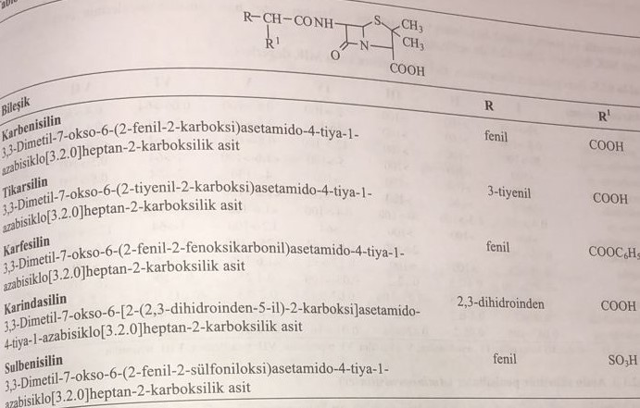
Carbenicillin and ticarcillin are obtained by chlorination of arylmalonic acid monoester with thionyl chloride followed by reaction with 6-aminopenicilanic acid. It is possible to acylate directly over the amino group of 6-aminopenicilanic acid with monoesters of arylmalonic acid in the presence of isobutyl chlorocarbonate and triethylamine, which is an active ester method with some patent studies. Thus, pure and economical production is carried out.
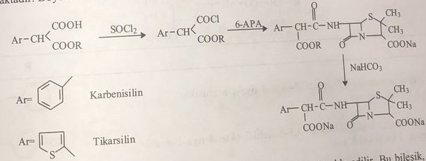
As a result of the interaction of phenylacetic acid with sulfur trioxide, 2-phenyl-2-sulfoacetic acid is obtained. These compounds are converted to thionyl chloride acid halide. Then sulbenicillin is obtained by interaction with 6-aminopenicilanic acid.
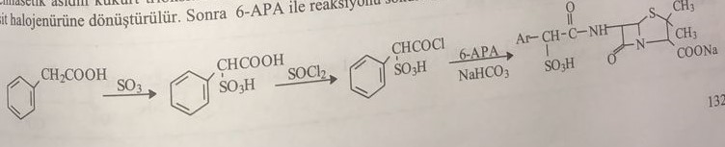
Carfecillin is the phenyl ester of carbenicillin. As in the synthesis of carbenicillin ticarcillin, phenylmalonic acid is obtained by the reaction of monophenyl ester with 6-aminopenicilanic acid.
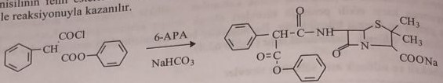
The MIC value of penicillins obtained biosynthetically and synthetically and used in clinical practice is listed in the table below.
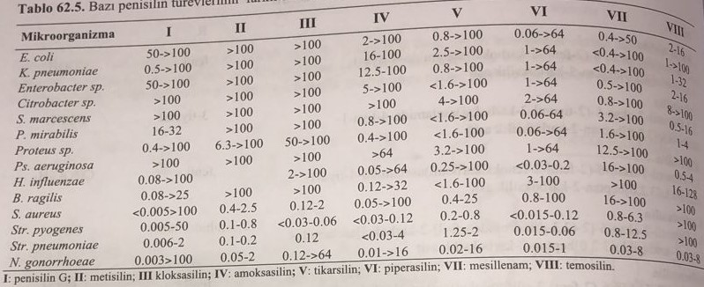
Aminopenicillins
This group of compounds are derivatives resulting from the addition of an amino group to a methylene group in the phenylacetic acid side chain. A phenyl ring can be attached to a methylene group just as an amino group can be attached.
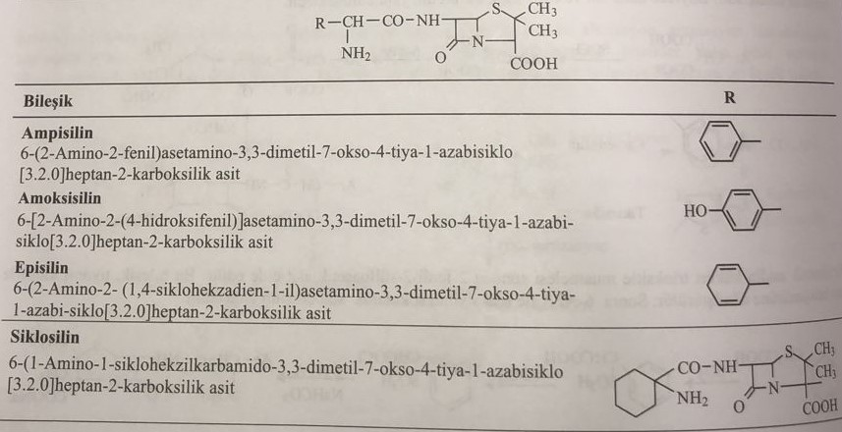
These compounds were introduced into clinical practice in the period from 1961 to 1972, ampicillin and amoxicillin are widely used. The spectrum of action is wide enough, absorption when taken orally is good. Pharmacokinetic properties, such as oral absorption and distribution in the body, are enhanced due to the esterification of the carboxyl group in the second position.
Depending on the pH of the biological environment, they can be in the form of cations, anions and interions (zwitter-ions) due to the main amino- and carboxyl functional groups in the second position of the aminopenicillins molecule. The following diagram shows this process:
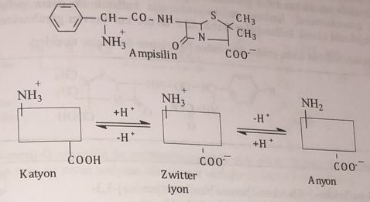
1) The cation of ampicillin is formed at the pH of the stomach and absorption decreases because of the ionization of the drug.
2) In the small intestine, a zwitter-ion is formed, absorption of the drug is carried out by active transport.
3) The anion is formed by deprotonation in the lower parts of the small and large intestine, so the absorption of the drug decreases and it is excreted from the body with feces.
Derived prodrugs were obtained to change these ionization properties of aminopenicillins and increase their absorption.
To obtain this group of penicillins, it is necessary to first protect the amino groups that are transferred by an acid component that forms a side group, and then combine the carboxyl group with 6-aminopenicilanic acid. For this, amino groups of D-phenylglycine, D-(4-hydroxyphenyl)glycine and D-(1,4-dihydrophenyl)glycine are introduced into the reaction with methylacetoacetate. The used sodium salt of Schiff's base is called Deine's salt. Then these compounds react with 6-aminopenicillanoy acid in the medium of ethyl chloride or isobutyl chloride and triethylamine.
Among the aminopenicillins, the cyclocillin molecule retains amino and carboxyl groups in the cyclohexane ring. For its synthesis, N-carbonic anhydride of 1-amino-1-cyclohexanecarboxylic acid is first obtained as a result of reaction with phosgene or triphosgene. The drug is obtained as a result of the reaction of 6-aminopenicillanoic acid with this anhydride.
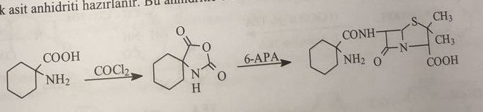
Prodrug derivatives of aminopenicillins
These preparations were synthesized to eliminate the anionic properties of either the carboxyl group or the cationic properties of the amino group of aminopenicillin derivatives. Thus, the dependence of the molecule on oral absorption has been eliminated. At the same time, the physico-chemical properties of the molecule are regulated according to pharmaceutical preparations. For this, the carboxyl group is esterified to an alcohol. The amine group was also made nonpolar by acylation with a carboxylic acid.
Derivatives made on the amine group (acylureide penicillins)
Alkylation with alkylating agents, acylation with acids, and Schiff base formation with aldehydes are possible when looking at the chemical coupling reactions of the amine group. The Schiff base of the alkyl derivatives of these products has proton-accepting and indirectly cation-forming properties. However, the cationic properties of the amino group disappear in acyl derivatives. For it, only non-polar acyl derivatives are used as medicinal preparations. Of these compounds, only ampicillin and amoxacillin are preparations obtained as a result of direct acylation of the amino group they hold in the chain with heterocyclic carboxylic acids and developed for use in hospital infections in general. It is used in the clinic in the form of infusion and injection. It is shown in the table:
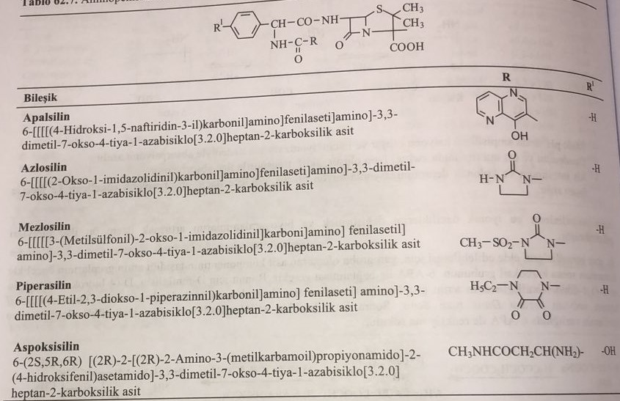
An active ester is prepared from apalsilin 4-hydroxy-1,5-naphthyridine-3-carboxylic acid in the medium of ethyl chlorocarbonate and triethylamine. Then the reaction with ampicillin-triethylamine salt is carried out. In the synthesis of piperacillin, first of all, acylated phenylglycine is obtained by combining the amine group obtained from the reaction of 4-ethyl-2,3-dioxopiperazine-1-carboxyl chloride with phenylglycine to 6-aminopenicilanic acid. This acylation occurs via an imidazolinone carboxyl acyl transfer reagent.
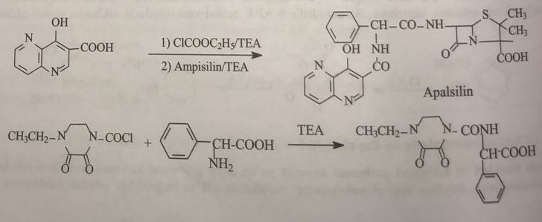
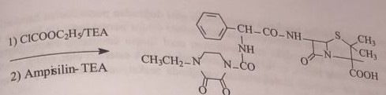
Azlocilin is obtained by reacting 1-chlorocarbonylimidazolidin-2-one with triphosgene and ampicillin in triethylamine. Mezlocilin is obtained from the reaction of 1-chlorocarbonyl-3-methylsulfonyl-imidazolidin-2-one formed as a result of the reaction of imidazolidin-2-one with methanesulfonyl chloride followed by triphosgene with ampicillin in triethylamine medium.
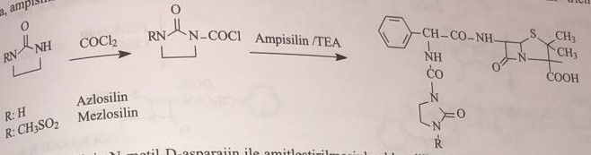
Aspoxycillin is obtained by amidation of amoxicillin with N-methyl-D-asparagine. For this, n-methyl-D-asparagine chloride is introduced into the reaction with amoxacillin triethylamine salt in anhydrous sodium bicarbonate medium.
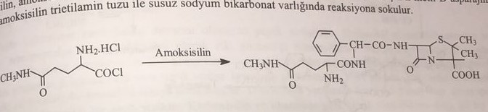
Derivatives obtained over the carboxyl group
The oral absorption of these compounds, obtained by esterification of the carboxyl group with various alcohols, is extremely high, and their bioavailability is clinically desirable. These derivatives are called diester prodrugs. Commonly used acyloxyalcohols, ethoxycarbonyloxyethanol, benzoisofuran-3-oxo-1-ol, pivaloyloxymethanol to form diesters.
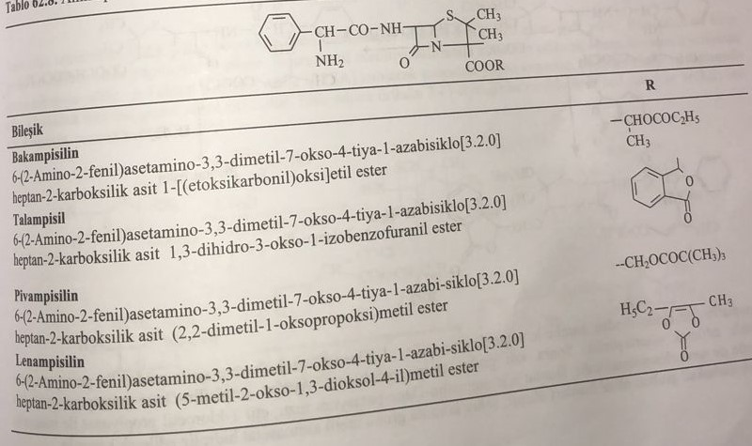
In addition to obtaining these complex esters using ampicillin, it is also possible to prepare them directly using penicillin. Using Penicillin G, the first corresponding ester is synthesized, then the esters of Alkoxybenzylpenicillin are obtained via the enol form of the amide group in the sixth position with methanol, n-propanol or isobutanol in quinoline medium with phosphorus pentachloride. This azomethine chloride derivative is hydrolyzed with water to obtain 6-aminopenicilanic acid esters, pivampicillin, thalampicillin, bacampicillin and lenampicillin are obtained by reacting with phenylglycine chloride in isobutyl chlorocarbonate medium.
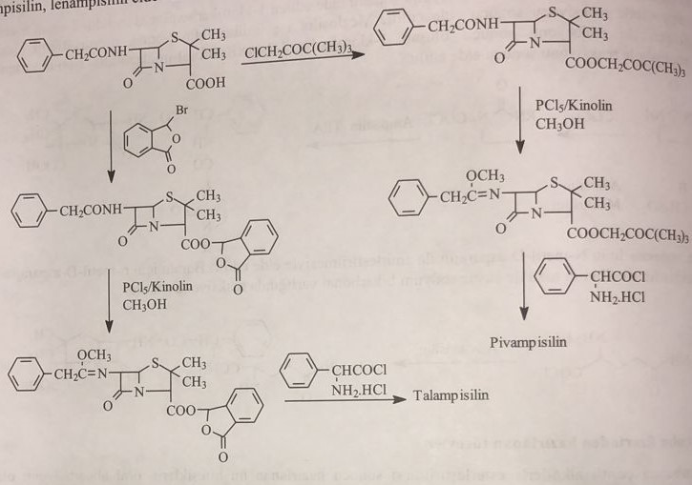
When talampicillin and pivampicillin are obtained using ampicillin, the potassium salt of ampicillin is sequentially reacted with 3-bromobenzoisofuran-1-one or pivaloyloxymethyl chloride. Then, methyl acetoacetate, an amine protecting group, is hydrolyzed and removed from the molecule.
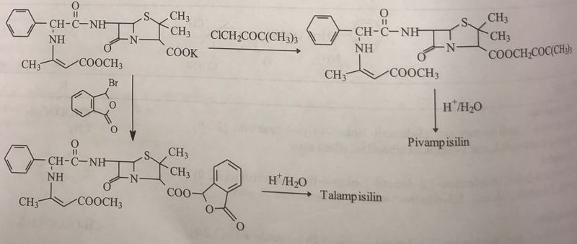
Baccampicillin is synthesized using azidocillin. 1-Chloroethyl ethoxycarbonate reacts with the potassium salt of azidocilin. The azide group is then reduced to an amine. At the same time, the synthesis is carried out using ampicillin potassium salt. For this purpose, ampicillin potassium salt is reacted with ethyl 1-chloroethyl propionate to obtain alcohol biesters of carboxyl groups, then methyl acetoacetate, which is a protective group, is hydrolyzed and removed from the molecule.
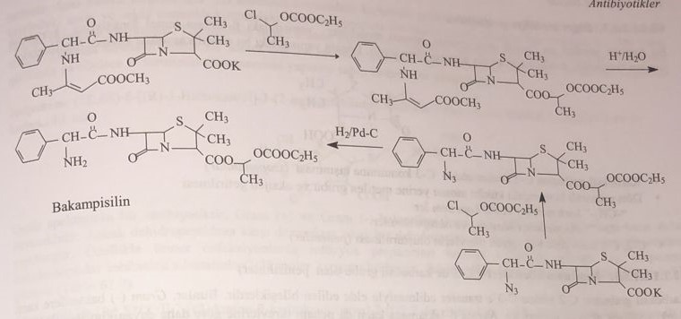
C-6 subunit penicillins
Penicillins have been found to inhibit the transpeptidase that provides transfer from the D-alanine-D-alanine region of the peptide chain that forms the cell wall against bacteria. It was determined that the β-lactamase secreted by bacteria does not affect the cephalosporins that retain the α-methoxy group in the seventh position from the cephalosporin derivatives, and this methoxy group protects the β-lactam ring from a steric point of view. In 1981, temozyl was discovered by Slocombe and his colleagues. Temocillin has a half-life of 4-5 hours and is a broad-spectrum and β-lactamase-resistant compound. It is a penicillin with more clinical advantages compared to carbenicillin and ticarcillin.
Temocillin: (6S)-6-[2-carboxy-2-(3-thienyl)acetamido]-6-methoxy-3,3-dimethyl-7-oxo-4-thia-1-azabicyclo[3.2.0] heptane 2-carboxylic acid
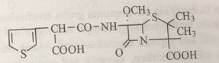
In the synthesis of temocillin, an ester is obtained from 6-aminopenicilanic acid. With benzaldehyde, the amine group is protected by deriving an amine from benzyl. Then, by reacting with methyl methylthiosulfonate, the thiocyanate group is added to the sixth position. The azomethine structure is cleaved by heating p-toluene with sulfonic acid. A methoxy group is added to the sixth position with mercuric chloride and methanol. Temocillin is obtained by reacting the obtained product with 2-(3-thienyl)malonyl chloride benzyl ester.
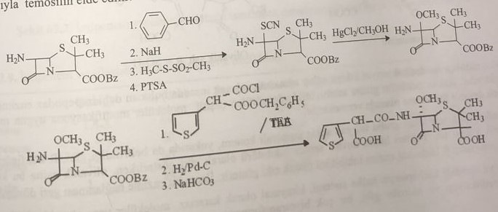
Other modified penicillins
The most important studies conducted in this regard are the derivatives obtained by molecular modifications, which are prepared by preserving the β-lactam main function in the molecular structure of penam. These modifications in the penam structure are as follows:
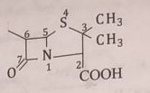
1) Transfer of carbonyl from the second position to the third position (isopenams)
2) Replacement of the sulfur atom in the fourth position with a methylene group and oxygen
3)CH2 for carbapenam and kabapenems
4)-O- for oxopenam (kalavam) and oxopenems
5)Obtaining derivatives (penems) with double bonds between C-2 and C-3
Isopenam compounds (Penicillins with a carboxyl group attached to the third carbon)
They are compounds obtained by transferring the carboxyl group to C-3 instead of C-2. At the same time, they are more stable compounds against β-lactamase compared to penam derivatives. Clinical trials of my two samples below are ongoing. In these examples, instead of C-2, one of the methyl groups at C-3 was replaced with a carboxyl group, and the other methyl group was replaced with 1,3-diazolidin-2-one groups. But by replacing the –NH group in the 1,3-diazolidin-2-one structure with different guanidine structures, compounds with a wider antibacterial spectrum were obtained.
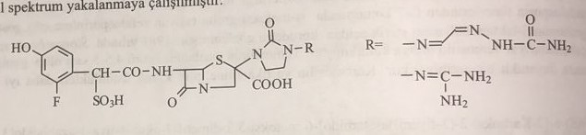
Carbapenam and carbapenem penicillins
Thienamycin isolated from Streptomyces cattleya by a research group of MSD (Merck Sharp Dohme) in 1970 and olivanic acid 7-oxo-(R)-1-azobicyclo[3.2. 0]hept-2-ene-carboxylic acid retains the structure. But the biological effects of these two compounds are quite different. While thienamycin has an antibacterial effect, olivanic acid acts as a penicillinase and β-lactamase inhibitor. The main structure in these derivatives is carbapenam, the asymmetric carbon atom in the eighth position is in thienamic (R) configuration, and in olivanic acid (S) configuration.
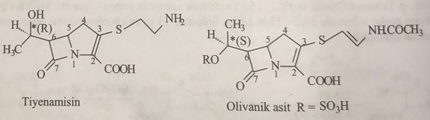
Although thienamycin has a very good antibacterial effect, it is quite resistant to the dihydropeptidase enzyme found in humans. But the molecular structure of the penicillin group, suitable for various molecular modifications found in antibiotics, allows the synthesis of many derivatives.
As shown above, the eighth position, which holds the alcohol group in the side chain of thienamycin, is in the R configuration, and with such a steric structure, it acts as an inhibitor of bacterial cell wall synthesis, while this position in olivanic acid is in the S configuration and acts as an inhibitor of β-lactamase. The combination of the drug with this enzyme is irreversible.
Thienamycin and its carbapenam ring system have a chemically discontinuous molecular structure and undergo many reactions of biotransformation, such as oxidation, reduction and hydrolysis in a biological environment. For this reason, a number of structural-active studies were conducted for more stable derivatives by obtaining different derivatives from the carboxyl group in the second position to the side chain in the third position and the hydroxyl group in the eighth position. In these studies of the relationship between molecular structure and activity conducted for the thienamycin molecule, molecular stability was achieved due to the conversion of the amino group into an amide and the preservation of activity in the compound. Thus, imipenem with the structure of N-formimidoylthienamycin was obtained.
Imipenem: (5R, 6S) – 6 - [(R)- 1- hydroxyethyl]-3-(2-imino methylamino ethylthio) -7-oxo-1-aza-bicyclo [3,2,0] hept-2- ene - 2-carboxylic acid
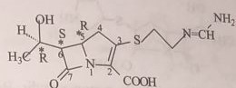
It is a broad spectrum antibiotic. They act against gram(+) and gram(-) bacteria. It is more resistant to β-lactamase. But it is unstable against dihydropeptidase enzyme, it is used in combination with an inhibitor. It is used as an infusion, especially for urinary system infections. For this, imipenem is used in a 1:1 ratio with cilastatin, a dihydropeptidase inhibitor. The pharmacokinetic properties of this compound are listed in the table below.
Cilastatin: [R-[R*,S*(Z)]]-7-[2-Amino-2-carboxyethyl)thio]-2-[[2,2-dimethylcyclopropyl)carbonyl]amino]-2-heptanoic acid
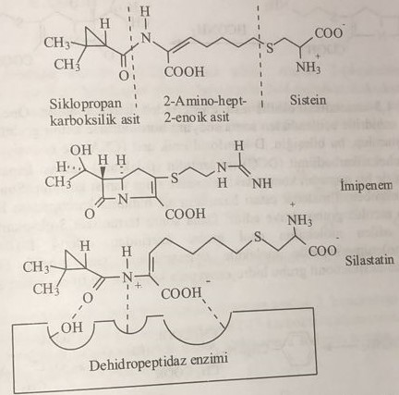
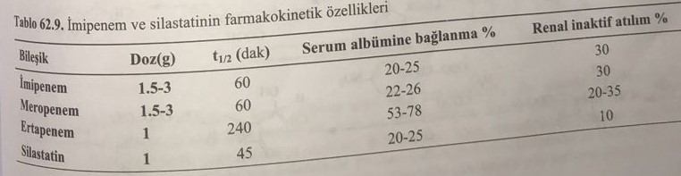
As with β-lactamase inhibitors, cilastatin acts as a substrate that binds competitively to dehydropeptidase. Thus, it prevents the enzymatic degradation of imipenem.
Meropenem: (5S,6S)-6-[ (R)-hydroxyethyl]-3-[2-(dimethylaminocarbonyl)pyrrolidin-3-yl)thio-7-oxo-1-azabicyclo[3,2,0]hept- 2-ene-2-carboxylic acid
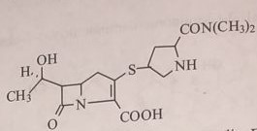
The second compound from the carbapenem group of β-lactam antibiotics is meropenem. This derivative is used in combination with the dehydropeptidase inhibitor cilastatin, such as imipenem. It is resistant to dehydropeptidase enzyme and has a stronger effect than imipenem.
Imipenem is obtained by reacting thienamycin with formamide. Since thienamycin is not obtained in certain purity by fermentation, imipenem is prepared by synthetic route.
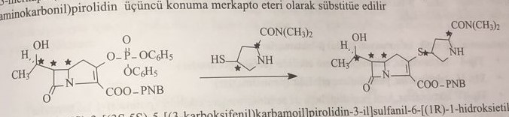
Diesters of 1,3-acetonedicarboxylic acid are used for the synthesis of thienamycin. A Schiff base is obtained with the first benzyl amine. After acylation of this product with acetic anhydride, the ketone group is reduced to a binary alcohol with sodium borohydride. From here, a lactone structure is formed, and this compound is separated into enantiomers with D-camphosulfonic acid. The azetidine ring is closed with dicyclohexylcarbodiimide. In this obtained derivative, the diamine group in the first position is first protected with n-butyldimethylsilyl chloride. Then malonic acid is prepared with p-nitrobenzyl chloride to mono (4-nitrobenzyl)malonate ester, thereby obtaining a carbapenam ring. For this, the methylene group is activated by the diazo transfer reaction. The 3-oxocarbapenam ring is then obtained by thermolysis. Diphenyl phosphate ester is obtained over the enol group of the molecule enolized with diphenyl phosphate. Thienamycin side chain is added to the molecule with 2-(4-nitrobenzyloxycarbonylamino)ethylmercaptol. The 4-nitrobenzyloxycarbonyl group is hydrogenated by palladium carbon catalysis to form thienamycin.
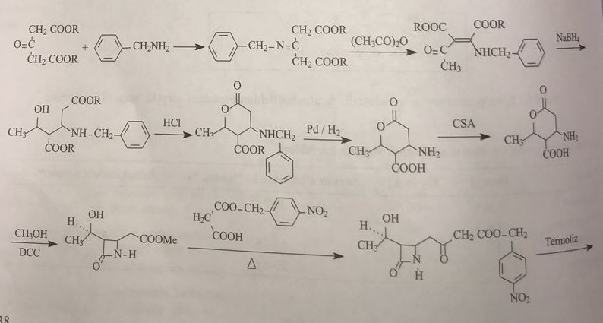
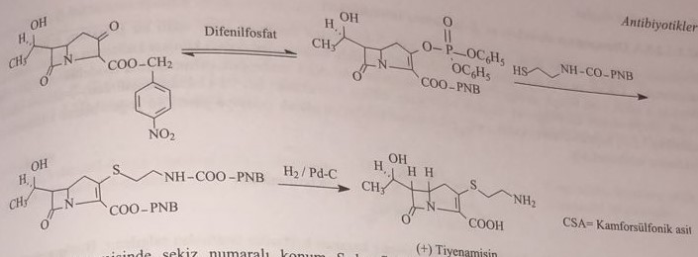
In the obtained thienami, the eighth state is in the S configuration. To obtain the active isomer, the compound is reacted with diethyl diazodicarboxylate in triphenylphosphate medium to obtain the R isomer.
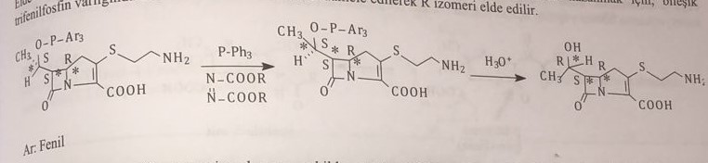
Meropenem is synthesized in a similar way to the synthesis of thienamycin. But in the addition of 2-(4-nitrobenzyloxycarbonylamino)ethyl mercaptol and 2-aminoethylmercapto to the third position, 3-mercapto(2-dimethylaminocarbonyl)pyrrolidine is used instead of 2-(4-nitrobenzyloxycarbonylamino)ethylmercaptol, the diphenyloxyphosphate group is removed, and 3-mercapto (2-dimethylaminocarbonyl)pyrrolidine is conjugated to the third position as a mercapto ester.
Ertapenem: (4R,5S,6S)-3-[(3S,5S)-5-[(3-carboxyphenyl)carbomoyl]pyrrolidin-3-yl]sulfanyl-6-[(1R)-1-hydroxyethyl]-4 -methyl-7-oxo-1-azo]azabicyclo[3.2.0]hept-2-ene-2-carboxylic acid
As in the synthesis of ertapenem meropenem, analogous to the synthesis of thienamycin, the diethoxyphosphate group in the third position is combined with 3-mercapto[2-(3-carboxyphenyl)aminocarbonyl]pyrrolidine instead of 3-mercapto (2-dimethylaminocarbonyl)pyrrolidine, and the diethoxyphosphate group is attached to the molecule. Ethylhexanoic acid is further reacted with sodium in ethyl acetate to form a salt.
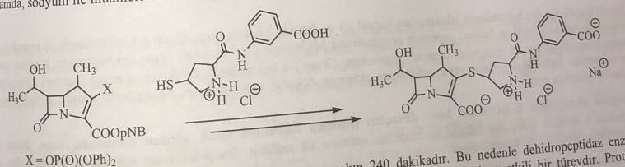
Ertapenem has a significantly longer half-life (240 minutes) than imipenem. Therefore, dehydropeptidase is used both parenterally and orally without the need for an enzyme inhibitor. It shows a partial depot effect. The protein binding property is less than that of imipenem, and sensitivity to β-lactamase is observed very little. This group of antibiotics is used especially in mixed infections. While imipenem and meropenem are used intravenously at a dose of 1.5-3g/day, ertapenem is used at a dose of 1g/day. In particular, it should not be used together with antiviral drugs such as ganciclovir. At this time, severe contractions are observed.
Oxopenam derivatives and β-lactamase inhibitors
Olivanic acid isolated from Streptomyces olivaceus was obtained as a β-lactam compound effective against β-lactamase enzyme. It has no clinical use due to its toxic and irreversible enzyme inhibitor properties. However, β-lactamase inhibitor antibiotic research is used in the development of new compounds resistant to β-lactamase. In 1976, clavulanic acid "3-(2-hydroxyethylidene)-7-oxo-4-oxa-1-azabicyclo[3.2.0]heptane-2-carboxylic acid" obtained from Streptomyces clavuligerus culture was included in the treatment as a β-lactamase inhibitor. done and widely used.
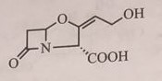
Penicillin-hydrolyzing enzymes are secreted especially by penicillin-resistant bacteria. These are called penicillinase or β-lactamase. Lactamases produce penicilloic acid by cleaving the lactam structure of β-lactam antibiotics, similar to hydrolytic reactions in alkaline media.
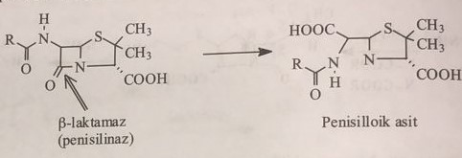
The most important reason for the development of resistance to β-lactam antibiotics in bacteria is the induction of β-lactamase secretion. This process is very important from a clinical point of view. The β-lactamase enzyme is produced by the genetic code in chromosomes or by the formation of a resistant plasmid. β-lactamases were classified by Sykes and Mathew:
1) Chromosomal (code with genetic information) β-lactamase.
a) β-lactamases of type I are active against cephalosporins (cephalosporinases)
b) type II β-lactamases are active against penicillins (penicillinase)
c) β-lactamases of type IV are active both against penicillins and against cephalosporins (lactamase polymorph-1).
2) β-lactamase encoded by a resistant plasmid
a) β-lactamases of type III are active against penicillin, cephalosporin and monobactams (polymorph-2-lactamase)
b) β-lactamases of type V are active against penicillin, cephalosporin, monobactam and isoxazolylpenicillins (multifunctional lactamases).
Usually, lactamases of gram(+) bacteria are localized inside the capsule and outside the capsule, and in gram(-) bacteria they are localized in the periplasmic part of the capsule and the bacterial wall along the edge of the inner membrane. While gram(+) bacteria secrete β-lactamase, synthesized in the cytoplasm, directly into the environment, in gram(-) bacteria β-lactamase is released only during bacterial cell division or is introduced into the infectious environment. Therefore, it is very difficult to treat infectious patients caused by these bacteria.
The resistance of penicillin derivatives to the action of β-lactamase is ensured by the protection of the β-lactam ring from a steric point of view or by combining the drug with an active compound specific to β-lactamase. The most important of these compounds-inhibitors of β-lactamase are listed in the table.
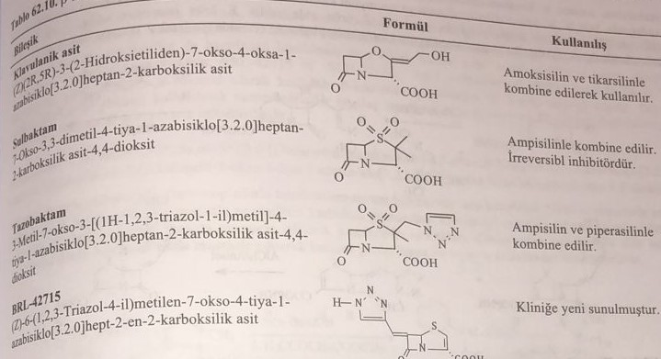
Clavulanic acid is produced biotechnologically by fermentation method. Although there is a synthesis method, it is economically more convenient to obtain the compound biotechnologically. Three other β-lactamase inhibitors are obtained by synthetic method.
6-aminopenicilanic acid is used for the synthesis of sulbactam. For this, the amino group of 6-aminopenicilanic acid is first diazotized with nitric acid. Then the sixth state is brominated with bromine. Dibromopenicilanic acid is reacted with potassium permanganate (permanganate) in acetic acid medium and the thioether group is oxidized to the dioxide group. The dibromo group in the sixth position is reduced with hydrogen gas under Pd-C catalysis.
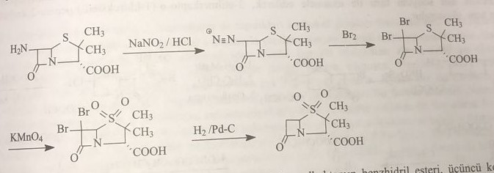
Sulbactam is used for the synthesis of tazobactam. For this, sulbactam benzhydryl ester is brominated with bromine at one of the methyl groups in the third position to form 3-azidomethyl-3-methyl-7-oxo-4-thia-1-azabicyclo[3.2.0]heptane-2-carboxyl-4,4 with sodium azide. -dioxide is obtained. For this, tazobactam is obtained by forming a 1,2,3,-triazole ring as a result of dienophilic cyclization from the reaction with vinyl acetate.
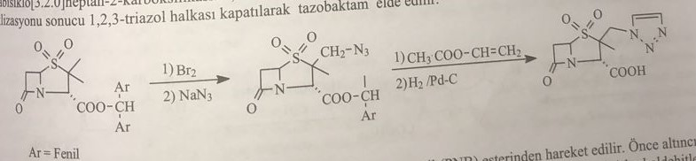
The p-nitrobenzyl (PNB) ester of 6-bromopenem-4-carboxylic acid is used for the synthesis of BRL 42715. Using bromine in the first state, lithium salt of triphenylamine is obtained with lithium. As a result of its reaction with 1-methyl-1,2,3-triazole-4-carbaldehyde, the triazole ring is attached to the sixth position. Lithium is removed by adding acetic acid. "E" and "Z" isomers obtained by reacting with N,N,N,,N,-tetramethylethylenediamine and ammonium chloride in dimethylformamide environment in metallic zinc medium are separated by crystallization and Z isomer is purified. And product E is isomerized. E and Z are separated by recrystallization. This isomer is converted to the Z isomer by heating in aluminum chloride/anisole medium.
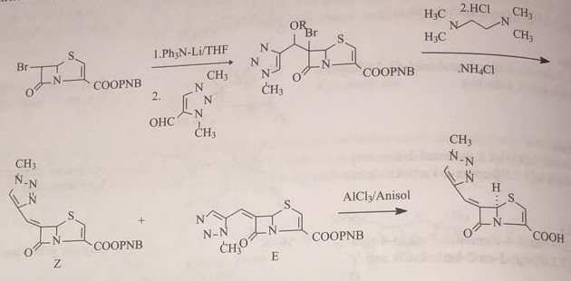
Penems
Penems are compounds that form a double bond between carbon atoms in the second and third positions of the thiazole ring, and unlike carbapenems, they retain the sulfur atom in the fourth position. The second compound in phase III outside of BRL-42715 is SCH-29482. This compound has a very broad lactamase inhibitory property. It is especially active against Type-I and II lactamases. The active isomer is the Z isomer.
6-aminopenicilanic acid is used for the synthesis of SCH-29482. In the first step, 6-bromopenicilanic acid is synthesized from 6-aminopenicilanic acid. In the reaction with acetaldehyde in ethylmagnesium bromide medium, the hydroxyethyl group is added to the sixth position. With trichloroethylchlorocarbonate, the hydroxyl group in the eighth position is protected. By opening the thiazole ring, 3-ethylmercaptopenem is reacted with ethyl xanthate and allyl-2-hydroxyacetate, and the sodium salt of 3-ethylmercapto-6-(1-hydroxyethyl)-penem-2-carboxylic acid is obtained.
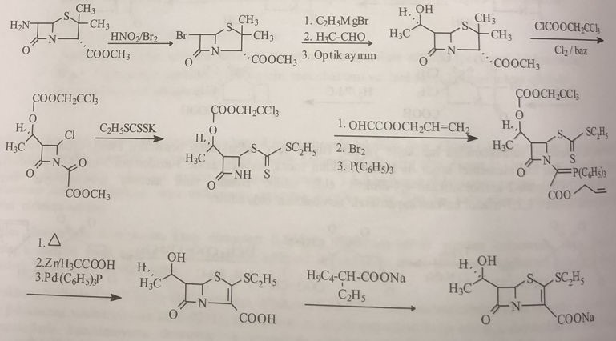
Combinations of β-lactamase inhibitors and penicillin derivatives as prodrugs
In order to increase the pharmacokinetic properties of active derivatives of penicillin and cephalosporins, it is included in treatment in combination with β-lactamase inhibitors. In particular, amoxacillin (Augmentin) with clavulanic acid is often used. Sulbactam, tazobactam, BRL-42715 and SCH-29482 show weak antibacterial activity. However, against β-lactamase type II-V, it is especially combined with β-lactamase inhibitors coded as R-plasmida. On the other hand, monomolecular prodrugs were obtained by the active ether method. Sultamicillin belongs to this group.
Sultamicillin: [2S-[2a(2R*,5S*),5a,6b(S*)]]-6-[(aminophenylacetyl)amino]amino]-3,3-dimethyl-7-oxo-4-thia- [[(3,3-dimethyl-7-oxo-4-thia-1-azabicyclo[3.2.0]hept-2-yl)carbonyl]oxy]methyl 1-azabicyclo[3.2.0]heptane-2-karbonovoy acid ester acid S,S-dioxide
During the synthesis of sultamicillin, the ampicillin salt is obtained with tetrabutylammonium hydroxide. The amino group is protected by methylacetoacetate. Then prepare chloromethyl ether on the carboxyl group of ampicillin with iodochlormethane. The obtained compound is subjected to interaction with tetrabutylammonium salt of sulbactam and diester of sulbactam and ampicillin is obtained. By reacting the amino group with p-toluene sulfonic acid, the protective group is removed and the tosylate salt is simultaneously obtained.
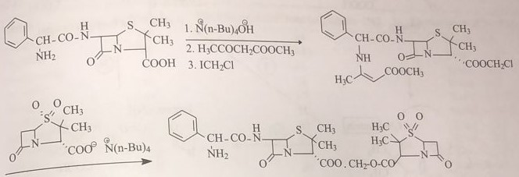
Сультамициллин представляет собой пролекарство, в котором ампициллин образует сложный диэфир по карбоксильным группам во втором положении с сульбактамом. Сначала в лечение включали лекарственную форму, полученную молярной смесью ампициллин/сульбактам (1:1). Эффект in vivo в этой структуре не всегда желаемого размера. Потому что наличие важных различий в кинетике абсорбции и элиминации обеих молекул свидетельствует о значительных рисках. Амфотерная природа ампициллина, особенно при пероральном применении, изменяется в зависимости от рН желудочно-кишечного тракта. В то же время, кроме различий в активности обоих препаратов, существуют и различия в периоде полувыведения. Считалось, что для устранения этого фармакокинетического несоответствия сульбактам наносят на организм в виде комбинированного пролекарства с антибактериальным ампициллином в форме диэфира, и, таким образом, сультамицил был приготовлен и заменил препараты физической смеси ампициллин-сульбактам. Сультамициллин применяют внутрь в виде тозилатной соли. При приеме внутрь хорошо всасывается из желудочно-кишечного тракта. Биоабсорбция составляет 90%. Он быстро гидролизуется эстеразами крови и действует в форме ампициллина и сульбактама.
Аллергия на пенициллин и механизм формирования.
Поскольку транспептидаза не синтезируется в эукариотических клетках, β-лактамные антибиотики не оказывают на эти клетки фармакодинамического действия, поэтому эти препараты малотоксичны. Однако они вызывают аллергические реакции, реагируя с веществами пептидной структуры в организме.
В первые периоды внедрения в клинику пенициллина и его биосинтетических производных при парентеральном применении наблюдалась реактивность, развивающаяся вплоть до анафилактического шока. Комплекс β-лактам-пептид, образованный соединением пенициллоевой кислоты, образованной из β-лактамной структуры, со свободной аминогруппой пептидов, вызывает аллергические реакции в организме как аллерген. При этом наиболее реакционноспособной является пенициллиновая кислота, являющаяся одним из продуктов распада пенициллина, и она связывается с биополимерами быстрее, чем пенициллиновая кислота, а образующийся комплекс более стабилен. Основными аллергенными продуктами в комплексах конъюгации, представленных на схеме, являются:
1) Продукт конъюгации, образующийся при ацилировании аминогруппы белков крови пенициллоевой кислотой
2) Продукт конъюгации, образующийся в результате аминолиза β-лактамного кольца непосредственно с аминогруппой белка
3) Продукт конъюгации, образующийся при повторном замыкании тиазолидинового кольца после соединения пенициллиновой кислоты с аминогруппой белка.
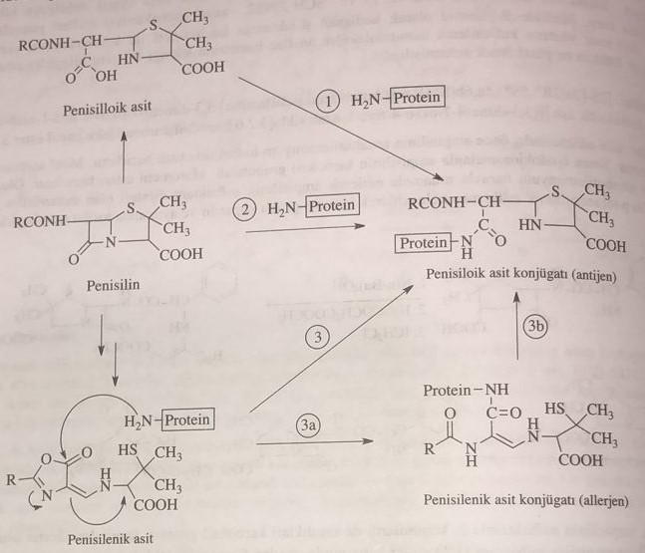
The property of causing an allergic reaction is present in all penicillins. A person with an allergy to one penicillin derivative may also be allergic to other β-lactam antibiotics. This is called a cross allergy. People who received penicillin treatment are more prone to this allergy. Children are less prone to developing allergies than adults. People prone to allergies are more prone to developing allergies to penicillin. This is a type I allergy caused by the formation of antipenicillin immunoglobulins-antibodies against conjugation antigens, which are formed when the amino groups of blood proteins are combined with penicillins. It manifests itself in the form of edema, itching and angioneurotic edema. It usually appears 2-30 minutes after taking the drug. The depth of the reaction reaches anaphylactic shock. The course of the type I reaction is a severe clinical condition. Allergies observed in the period from 1 to 72 hours after taking penicillin were very mild, no anaphylactic shock was observed after these reactions.
Sometimes a rapid type I reaction leads to anaphylactic shock. Nausea-vomiting, abdominal pain, swelling of the mucous membrane of the mouth and throat, laryngitis - these are only the first symptoms of anaphylactic shock. If you don't take measures against these symptoms, blood pressure drops, bronchi narrow and fainting occurs. These symptoms lead to death.
Allergic reactions of type II and type III are allergies that appear 72 hours after taking the drug and are based on the interaction of IgG and IgM antibodies with the penicillin-allergen complex. Rashes develop in the form of erythema and fever. Allergy of this type can develop to all β-lactam antibiotics. Due to dermatological symptoms, the use of penicillins and cephalosporins in the form of creams, ointments and powders is limited.
Determination of sensitivity to the use of β-lactam antibiotics.
Patients who will be clinically treated with penicillin and β-lactam antibiotics are recommended to undergo a sensitivity test. Some doctors make the mistake of testing directly with antibiotics. This intradermal test can cause a serious allergy. Therefore, the solution of N-benzylpencilylpolylysine (PPL) is used as a test sample to determine the sensitivity. The reliability index of this conjugate is higher than that of the sensitivity test with other β-lactams and penicillin-G. Tests with this allergen determine type I allergic reactions. For type II and type III reactions, 1000–2000 IU (3–5 mg) of penicillin-G are administered intravenously or orally. If the patient is under observation and no symptoms are observed, then there is no allergic reaction. Adrenalin 0.5-1 mg and glucocorticoid 5 μg/kg should be kept in reserve to prevent a severe allergic reaction observed during the test.
Biotransformation and pharmacokinetic properties of penicillins.
Pharmacokinetic properties of penicillins differ little due to the fact that their physical and chemical properties are close to each other. The half-life period from the plasma is short, proportional to the rate of degradation by β-lactamases. Pharmacokinetic properties of some penicillins are presented in the table.
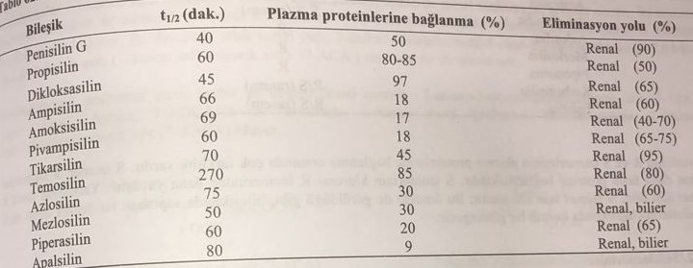
There are great differences in the binding of penicillins to plasma proteins. Ampicillin is 18% conjugated while isoxazolyl penicillins are 90% conjugated. This is a very good indicator for resistance to lactamases. Anti-lactamase and bacterial infections have an important influence on the doctor's choice in the clinical use of the drug. In addition to glomerular filtration, loop secretion also plays an important role in the renal elimination of penicillins. Some antirheumatic and uricosuric drugs that are acidic in this transport mechanism inhibit the reabsorption of penicillins. Therefore, these drugs cannot be used together with penicillins. Biotransformation reactions of penicillins occur in parallel with the reactivity of the β-lactam ring system. The product formed by enzymatic or non-enzymatic primary reactions is penicilloic acid. This substance is followed by decarboxylation to form peniloic acid and the thiazolidine ring opening reaction. Acylases cleave the 6-acylamino group in some penicillin derivatives to form 6-aminopenicilanic acid.
1) Aromatic hydroxylation and conjugation (acceleration of renal elimination) in derivatives containing a phenyl group in the side chain, as in benzylpenicillin and propicillin
2) Oxidation of the C5 methyl group on the isoxazole ring, as in isoxazolyl penicillins. Thus, it forms a more potent antibacterial metabolite (bioactivation).
Chirality in penicillins (stereochemistry of penicillins).
The configuration of C-2, C-5 and C-6 positions in 6-aminopenicilanic acid and the angle stereochemistry of the bicyclic structure were investigated. In many semisynthetic penicillin derivatives, radical coupling to the benzene structure forms a fourth asymmetric center. An example of this is aminobenzylpenicillins.
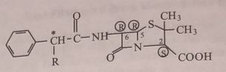
It was found that the R-isomer of ampicillin is more active than the S-isomer of aminobenzipenicillin derivatives. The β-lactam ring in the molecule is a pharmacophore group that provides activity. The more sterically protected the β-lactam ring, the higher its antibacterial activity. It is established that diastereomers with the fourth chiral center in the aminoacyl side chain show different kinetic properties. R- and S-isomers of propicillin differ greatly in binding to proteins, as well as in clearance and half-life. Examples of fourth asymmetric center holders are shown in the table.
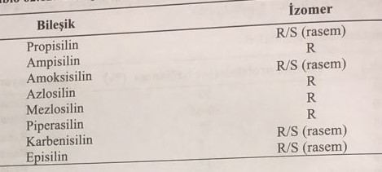
The binding properties of R- and S-isomers of temocillin with plasma proteins are different. Isomer S combines twice as much as isomer R. The clearance of isomer S is slower than isomer R. The half-life period is 4 hours for the R-isomer and 6 hours for the S-isomer. As you can see from these examples, compounds have a depot effect.

